**NATURAL FOOD AND ARTIFICIAL FEEDS AND THEIR IMPORTANCE IN FISH AND SHRIMP CULTURE**

**Natural food organism in pond**

A variety of natural fish food organism are found in water body. The natural food provides the constituents of a compete and balanced diet. The demand of natural food varies from species to species. For example catla prefer zooplankton and silver carp prefers phytoplankton. At younger stage, the fish may feed on plankton, and the same fish may prefer animal food as an adult.

**Recommended nutrient levels for shrimp feed on percentage fed basis**

|  |  |  |  |  |  |  |  |
| --- | --- | --- | --- | --- | --- | --- | --- |
| **Shrimp size (gm)** | **Protein (%)** | **Fat (%)** | **Fiber (%)** | **Ash (%)** | **Moisture (%)** | **Calcium (%)** | **Phosphorus (%)** |
| 0.0-0.5 | 45 | 7.5 | Max.4 | Max.15 | Max.12 | Max.2.3 | Min. 1.5 |
| 0.5-3.0 | 40 | 6.7 | Max.4 | Max.15 | Max.12 | Max.2.3 | Min. 1.5 |
| 3.0-15.0 | 38 | 6.3 | Max.4 | Max.15 | Max.12 | Max.2.3 | Min. 1.5 |
| 15.0-40.0 | 36 | 6.0 | Max.4 | Max.15 | Max.12 | Max.2.3 | Min. 1.5 |

(Source : Lin, 1994)

**Importance of Natural food**

Natural feeds have high protein and fat contents which promote the growth of the fish. Hence, it is necessary to increase the live food in the aquatic ecosystem to improve the growth to improve the growth of the fish.

Fish production in water body is directly or indirectly dependant on the abundance of plankton. Water quality determines the quality and quantity of plankton. Plankton are two kinds phyto plankton and zooplankton

**Phytoplankton**

Fishes consume the phytoplankton which is found abundantly in well managed ponds. Phytoplankton gives green colour to the water due to the presence of chlorophyll. Plankton are generally made up of mostly unicellular algae which are either solitary or coronial.

Phytoplankton are autotrophs. Algae of three major classes which from the main food in phytoplankton. These are chlorophyceae, cyanophyceae and bacillariophyceae.

**Chlorophycaea** These are called green algae due to the presence of chlorophyll. The chlorophyceae members useful as fish food are Chlamydomonas, Volvox, Eudorina, Pandorina, Chlorella, Oedogonium, Spirogyra, Pediastrum, Microspora, Cladophora, Clostridium, etc.

**Cyanophyceae** : These are commonly known as blue green algae. Examples are Nostoc, Oscillotoria, Anabaena, Microcystis, Spirulina, Merismopedia, Arthrospira etc.

**Bacillariophycaea** : These are called diatoms. They are unicellular organisms with different shapes and sizes. These may be yellow or golden brown or olive green in colour. The reserve food materials are fat The diatoms consumed by fish are Diatoma, Navicula , Cocconies, Synedra, Tabellaria, Meridion, Fragilaria, , Pleurosigma, Amphioleura, , Cyclotella, etc.

**ZOOPLANKTON**

Plankton consisting of animals is called zooplankton . Zooplankton is abundant in the shallow areas of water body.

**Protozoa** Protozoans are most primitive unicellular and microscopic. These organism are found abundantly in fish ponds are useful as natural fish food Eg. Amoeba, euglena, paramecium etc.

**Crustacea** The aquatic animals with 5 pairs of appendages and branchial respiration are included in the class crustacea. The crustaceans vary from microscopic to large animals . Crustacean form major component of zooplankton. In zooplankton the micro crustaceans are useful as food of fish and prawns. For example , nauplii of Artemia are used in prawn hatcheries.

**(a) Copepoda** : These are animals with 5 pairs to thoracic appendages , abdomen without appendages, forked telson, two pairs of antennae and body with head thorax, and abdomen. The copepods inhabit freshwater. The sizes of the body of the copepods is 0.3 to 3.5 mm. Eg. Cyclops, Mesocyclops, Diaptomus, etc, are useful as fish food organism.,

**(b) Cladocera :** Which are bivalved should shaped with or without shell, The size of these shelled crustacean varies from 0.2 to 3.0 mm. Eg. Daphnia, Ceriodaphnia, Moina. Sinocephalus etc are useful as fish food organism.

**(c) Ostracoda :** The animals with bivalved carapace Eg. Cypris, Stenocypris etc, are consumed by fish.

**Rotifera** Rotifera are readily from other planktonic material by the presence of their major ciliated wheel-like structure they are called wheel animalcules. range from 40 microns to 2.5 mm in size. Usually rotifers like Keratella Phlodina, Rotaria. Hexarthra, Filinia, Brachionus Epiphanes etc., are useful as food organism.

**Annelids** Animals with metameric segmentation , eucoel, nephridia and setae are included in the phylum annelida. The animals which belong to classes polychaeta and oligochaete are useful as fish food organism. These are found at the bottom of the water body are generally consumed by bottom-dwelling fish,. eg. Tubifex , Glycera and earth worm

**Insects** Animals with 3 pairs of legs of wings, jointed appendages and a chitinous body wall are included in class Insecta. Insects and their larvae form main food item of any fishes., Aquatic insects are often preyed upon by fish trout, catfishes murrels etc. Hemiptera, diptera , coleoptera, ephemeroptera and plecoptera insects dominate as fish food

Eg. Mosquito larvae, larvae of dragon flies belostomitide, odonat etc. .

**Mollusca** The animals with a soft body, shell and foot are included in the phylum Mollusca . Bottom-dwelling fish consume them. The gastropodes are found in the diet of carnivorous and omnivorous fishes.

**Amphibia** Amphibian The fishes consume the tadpoles among amphibians.

**Fishes** Carnivorous (piscivorous) fish feed on a variety of other adult fishes ,. Fish like murrels etc, feed on other fishes. Small fishes are consumed by some carnivorous fish. Some fishes are cannibalistic in nature.

**Prawns** Fishes also feed on decapods (prawns) . The carnivorous and omnivorous fishes feed on small prawns.

**Culture of Plankton for live food feeding**

Unialgae (algae belonging to same species) are obtained by the isolation and culturing in artificial conditions. Diatoms, chlorella are cultured in this way

Zooplankton like moina, artemia are cultured in artificial culture in prawn hatcheries. Lablab is a mixture of zoo and Phyto planktons which is cultured artificially

**Artificial feeds and their importance in fish and shrimp culture**

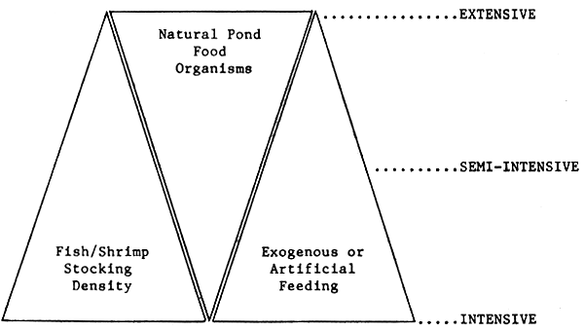

**Formulated feed**

Rearing of spawn, fry and fingerlings until they become stock able size and their subsequent culture in grow out ponds require appropriate and nutritionally balanced diet for enhancing production. This is been of the essential requisites in the development of aquaculture. The advantages of formulated feed are

1. Proper formulated feed are in replica of exact nutritional requirement of fish. Therefore by understanding the nutritionally well balanced feeds which could be formulated using low cost feed stuff available locally.

2. Ingredients of formulated feeds can complement one another and arise the food utilization rate.

3. Proteins can supplement one another so as to satisfactory improve most of the essential amino acids content of the feed, thereby raising the protein utilization.

4. Large quantities of feeds can be prepared at a time good shelf-life so to be convenient to preserve, which can be used at the time of supple mentary feeding.

5. Feed ingredient sources can be broadened with preferred and less preferred ingredients with additives like antibiotics and drugs to con trol fish disease.

6. High efficiency of feed can be achieved by judicious manipulation of feed ingredients and can be made commercially feasible.

7. By adding a binding agent to produce feeds, the leaching of nutrients in water is diminished and wastage is reduced.

8. Dispersing over large farm area is quite possible as formulated feeds are convenient transport. These are suitable for automatic feeding, for which automatic feed dispensing devices could be successfully employed.

**(a) Suspended :** It is required feed, prepared with Acetes, Squilla and clams . Its preparation is discussed in chapter VG.

**(b) Pelletised feed :** This si a nutritionally well balanced solid feed and can be used off the shelf as and when required. This type of feed contains only ingredients of precisely known as composition and for this reason such diets are very expensive.

**Use of Artificial Fish Feed: Merits & Demerits**

**1. Introduction:** Good nutrition in animal production systems is essential to economically produce a healthy, high quality product. In ormental fish farming, nutrition is critical. Fish nutrition has advanced dramatically in recent years with the development of new, balanced commercial diets that promote optimal fish growth and health and also body colour.

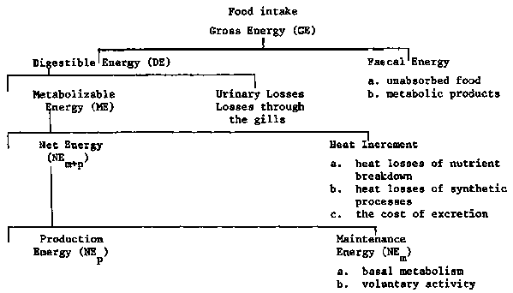2. **Types of feeds** 1. Natural fish feed- Live feed 2. Artificial fish feed Live feed: Live feed or fish food organisms are microscopic organisms naturally present in the aquatic environment as primary food for the larvae of fin fish and shell fish. Their size ranges from a micron to few millimetres. They are tiny forms which suits the mouth size of all kinds of fin fish and shell fish larvae.

3. • Prepared or artificial fish feeds may be either complete or supplemental. Complete diets supply all the ingredients (protein, carbohydrates, fats, vitamins, and minerals) necessary for the optimal growth and health of the fish.

4. Artificial feed may be of different kinds

**Pellets.** These may be floating or sinking pellets

**Flakes**- are flat in structure

**Granular form** – they are very small and round shape. They are similar to grains.

**Moist feed** – It is prepared daily and fed to fishes – the moisture content is 35%.

**Paste feed** – This is mainly prepared for young ones of all. The feed ingredients are made into paste and fed to the fishes squeezing through mesh.

5. **Preservatives**, such as antimicrobials and antioxidants, are often added to extend the shelf life of fish diets and reduce the rancidity of the fats. Vitamin E is an effective antioxidant. Commonly available commercial anti-oxidants are butylated hydroxyanisole (BHA), butylated hydroxytoluene (BHT) and ethoxyquine. Sodium and potassium salts of propionic, benzoic or sorbic acids, are commonly available anti-microbials added at less than 0.1% in the manufacture of fish feeds. Other common additives incorporated in the fish feeds are chemo attractants and flavourings, such as fish hydrolysates and condensed fish soluble (typically added at 5% of the diet). Basically, attractants enhance fish pallatibility and its intake.

6. **Storage Procedure** of Fish Feed: Freezer bags serve to store the prepared feeds, and using a bag vacuum sealer will greatly extend the shelf-life of both ingredients and the feed. The feed can be stored double bagged in the freezer but should be discarded after 6 months. Ideally, dried larval feeds are not frozen but stored in the refrigerator for no longer than 3 months.

7. **How to feed the Fish**? Feeding should be done at regular time everyday. It is vital that fishes are offered a relatively small amount of food, which should be consumed within 5 – 10 min of being placed in the tank. Overfeeding and under-feeding should be avoided. Overfeeding results in polluting water quality(ammonia concentration) due to accumulation of uneaten feed and faecal matter. Under feeding results reduced growth rate of fishes due to insufficient feed.

8**. Amount of Feed given**: Per day = Biomass × Percentage of body weight of feed per day

Biomass can be calculated using the following formula.

Biomass = Stocking density (in nos.) × Survival rate × Average body weight.

9. **Merits and Demerits of Artificial Fish Feed**:

Merits: Specifically formulated for aquacultural use.

These are properly balanced with different types of nutrients.

Contains essential nutrients to meet the requirements of different species.

Can be manipulated to suit developmental stages for a range of species.

Consistent quality.

Readily available. •

Wide variety and types.

Demerits: • Expensive to purchase . • Requires refrigerated storage. • Overfeeding with artificial feed may cause water pollution. • Improper storage may cause contamination.

**10. Conclusion**: artificial feeds are required for semi intensive and intensive practises. In intensive culture systems. Feed represents the major expense, often accounting for over 50% of total variable operating costs. This the development of feeds that are efficient and economical is fundamental to successful shrimp farming. This requires the understanding of nutritional